SEO Metadata
- Focus Keyword: best digital marketing agency in Bangalore
- Meta Title: Best Digital Marketing Agency in Bangalore | Off-Page SEO Strategy | Brewing Ideaz
- Meta Description: Discover how Brewing Ideaz can build online visibility as a digital marketing agency in Bangalore through local citations, quality backlinks, guest posting, and brand awareness.
- URL Slug: /off-page-seo-best-digital-marketing-agency-in-bangalore/

Secondary Keywords
- digital marketing agency in Bangalore
- best digital marketing company in Bangalore
- digital marketing services in Bangalore
- online marketing agency Bangalore
- SEO agency in Bangalore
- performance marketing agency Bangalore
- social media marketing agency Bangalore
- digital marketing company Bangalore
- digital marketing experts in Bangalore
- Brewing Ideaz Bangalore

Off-Page SEO Strategy: Best Digital Marketing Agency in Bangalore
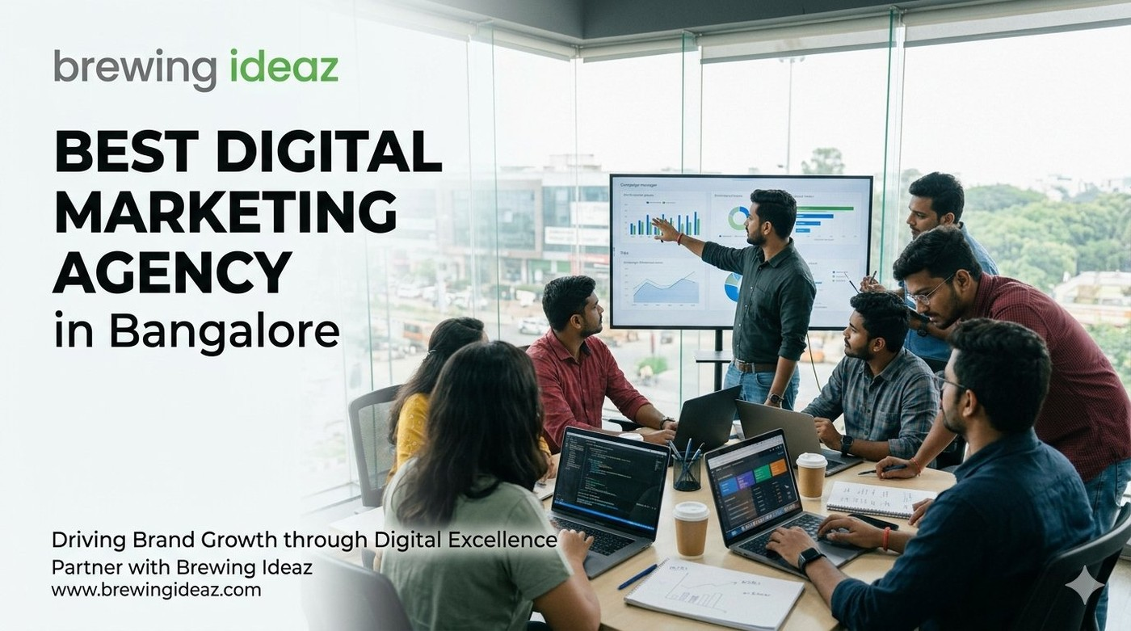
In today’s competitive digital landscape, having a well-designed website is only one part of building a strong online presence. Businesses also need visibility, credibility, and meaningful engagement across relevant online platforms.
For businesses searching for the best digital marketing agency in Bangalore, off-page SEO can help improve brand discoverability, build relevant online relationships, and connect with potential clients looking for digital marketing services.
Brewing Ideaz can strengthen its online presence through a structured off-page SEO strategy focused on relevant backlinks, local business listings, useful content, and authentic customer feedback.

1. Google Business Profile Optimization
Recommended actions include:
- Publish weekly posts that naturally include the primary keyword or close variations.
- Add genuine project results screenshots, team photos, and office images.
- Encourage honest client reviews mentioning digital marketing services and project experiences.
- Keep the business name, address, and phone number consistent across platforms.
- Respond professionally to customer feedback.
- Update business information whenever details change.

2. Local Citations and Business Directories
Brewing Ideaz can review and update relevant listings on:
- Justdial
- Sulekha
- IndiaMART
- Clutch
- Google Business Profile
- Bing Places
- Relevant marketing and agency directories

3. Backlink Building and Guest Posting Strategy
Brewing Ideaz can explore guest posting and content collaboration opportunities through:
- YourStory
- Medium
- LinkedIn Articles
- Marketing and startup blogs with Indian readership
- Relevant “Best Digital Marketing Agencies in Bangalore” listicles and round-ups

4. Recommended Anchor Text Strategy
- Exact-match keywords: best digital marketing agency in Bangalore
- Close-match keywords: digital marketing agency in Bangalore
- Branded anchors: Brewing Ideaz
- Natural descriptive anchors: our digital marketing team in Bangalore
Suggested distribution: 60% exact-match or close-match anchor text, 40% branded or natural anchor text.

5. Social Media and Community Engagement
- LinkedIn: Share the published blog with data-backed or insight-driven captions.
- X (Twitter): Post key takeaways from the article.
- Reddit: Participate genuinely in relevant communities such as r/Bangalore, r/indianstartups, r/marketing, and r/SEO.
- Facebook: Share useful content in relevant groups for Bangalore founders and marketers.
- LinkedIn Carousel or Video: Create a short presentation titled “How to Evaluate a Digital Marketing Agency in Bangalore.”

6. Client Case Studies and Testimonials
- Turn verified client results into detailed case studies.
- Publish genuine testimonials with client permission.
- Share project insights and marketing strategies.
- Highlight measurable outcomes where reliable data is available.
- Use relevant case studies as resources for outreach and content collaborations.

7. Local Media Outreach and Brand Mentions
- Pitch articles to local business and marketing publications.
- Share useful digital marketing insights with relevant newsletters.
- Contribute expert commentary on SEO and digital marketing topics.
- Monitor online brand and keyword mentions.
- Identify relevant websites for content collaborations.

8. Tracking and Reporting Off-Page SEO Performance
- Search impressions and clicks in Google Search Console.
- Rankings for the primary keyword and its variations.
- Referral traffic from guest posts and citations.
- Google Business Profile insights.
- Relevant backlinks and brand mentions.
- Conversions from organic and referral traffic.

Conclusion
A sustainable off-page SEO strategy combines accurate local business listings, relevant backlinks, useful content, authentic customer feedback, and consistent performance tracking. Brewing Ideaz can strengthen its digital visibility by building meaningful relationships, sharing useful marketing insights, and maintaining a consistent presence across relevant online platforms.

Book Your Consultation With Brewing Ideaz
Ready to strengthen your online presence in Bangalore? Get in touch with our team to discuss your goals.
Brewing Ideaz
Phone: (+91) 62915 47048
Email: info@brewingideaz.com
Corporate Office: Street No. 91 & 92, Sarjapur – Marathahalli Road, Carmelaram, Ambedkar Nagar, Chikkabellandur, Mullur, Bengaluru, Karnataka 560035

30 Frequently Asked Questions About Digital Marketing Agency in Bangalore
- What is off-page SEO? Off-page SEO includes activities outside a website that help improve its visibility, reputation, and authority, such as backlinks, brand mentions, reviews, and local citations.
- Why is off-page SEO important for a digital marketing agency in Bangalore? It helps potential clients discover the business through relevant websites, local listings, referrals, and brand mentions.
- What is the best off-page SEO strategy for a digital marketing agency in Bangalore? A balanced strategy includes accurate local listings, relevant backlinks, useful content distribution, genuine customer reviews, and regular performance tracking.
- How does Google Business Profile help local businesses? It helps eligible businesses display accurate information and become discoverable through Google Search and Maps.
- Which directories can a Bangalore digital marketing agency use? Businesses can consider Google Business Profile, Bing Places, Justdial, Sulekha, IndiaMART, Clutch, and relevant marketing directories, depending on eligibility.
- What is a backlink? A backlink is a link from another website that directs users to your website.
- How do backlinks help SEO? Relevant, editorially earned backlinks can help search engines discover pages and may contribute to authority and relevance signals.
- What is guest posting? Guest posting involves publishing useful content on another relevant website, often with an appropriate author or business reference.
- Where can a digital marketing agency publish guest articles? Agencies can explore relevant marketing publications, startup websites, business blogs, and industry websites that accept useful contributions.
- What is anchor text? Anchor text is the clickable text in a hyperlink that describes or identifies the linked page.
- What anchor text should a digital marketing agency use? Use natural, descriptive, and branded anchor text rather than repeatedly forcing exact-match keywords into links.
- How important are social media shares for SEO? Social media shares can increase content exposure and attract visits or mentions, but they do not guarantee improved search rankings.
- Which social media platforms can a digital marketing agency use? LinkedIn, X, Facebook, and relevant online communities can help distribute content and connect with potential clients.
- How can a business get genuine client reviews? Ask clients politely for honest feedback after completing a project and follow the relevant platform’s review policies.
- What is NAP consistency in local SEO? NAP stands for Name, Address, and Phone number. Consistency helps customers and platforms identify the same business across listings.
- Can off-page SEO work without paid advertisements? Yes. Off-page SEO can focus on organic activities such as earning relevant backlinks, maintaining business listings, and sharing useful content.
- How long does off-page SEO take to show results? The timeline varies depending on competition, website history, implementation quality, and other factors. Results are not guaranteed within a specific period.
- What role does content play in off-page SEO? Useful content gives other websites and audiences a reason to reference, share, or discuss the business.
- Should blog images include the company logo? A relevant branded image can support brand recognition. The logo should be clear, and the image should match the article’s topic.
- How can off-page SEO performance be tracked? Google Search Console, analytics reports, business listing insights, and backlink monitoring tools can help track performance.
- Is off-page SEO only about backlinks? No. It can also include local citations, reviews, brand mentions, digital PR, and content outreach.
- Can local SEO be part of off-page SEO? Yes. Local listings, citations, and customer reviews are commonly included in local off-page SEO activities.
- How should a business choose guest-posting websites? Look for topical relevance, a genuine audience, editorial standards, and website credibility. Avoid link schemes.
- What is digital PR in SEO? Digital PR involves earning media coverage and brand mentions by sharing useful stories, research, expert insights, or resources with relevant publishers.
- How can brand awareness support SEO? Brand awareness may lead to more branded searches, website visits, mentions, and links, although results vary.
- Which tools are useful for off-page SEO? Google Search Console, analytics tools, backlink analysis platforms, and Google Business Profile insights can help monitor different aspects of performance.
- Do online reviews directly improve search rankings? Reviews can influence customer trust and local visibility, but rankings depend on multiple factors and are not guaranteed.
- What is a case study in digital marketing? A digital marketing case study explains a project’s objectives, strategy, execution, and verified outcomes.
- Can a Bangalore digital marketing agency get featured in local publications? Yes. An agency can pitch relevant stories, expertise, or project insights to local publications and business communities, though coverage is not guaranteed.
- How can I contact Brewing Ideaz for digital marketing services in Bangalore? You can contact Brewing Ideaz by calling or WhatsApping +91 62915 47048 or emailing info@brewingideaz.com to discuss your digital marketing requirements.

